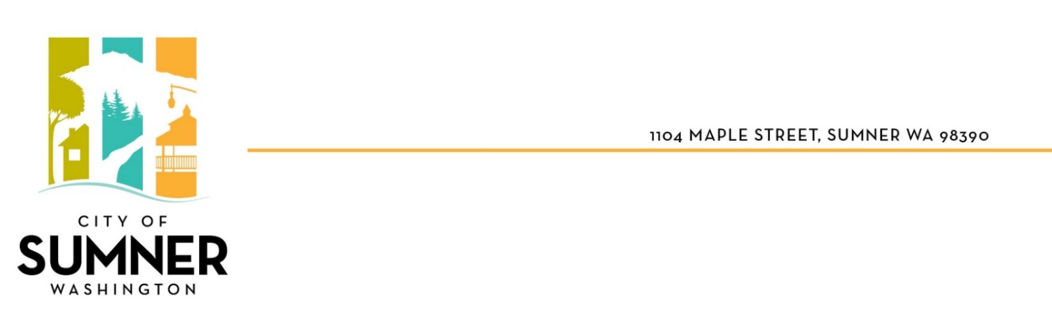
STAFF REPORT

DATE: December 2, 2024
TO: SUMNER CITY COUNCIL
FROM: Ryan Windish, Director of Economic and Community Development
RE: Zoning Code Text Amendment – CRITICAL AREAS REGULATIONS
File #: CTA-2024-0003

I. BACKGROUND

Purpose: The City Council is being asked to take action on Ordinance No. 2909 adopting the 2024 Comp Plan update on Critical Areas Regulations.

Why amendments are being proposed

The State Growth Management Act (GMA) requires cities to complete a “10-year periodic update” of their Comprehensive Plans. Sumner’s 10-year update will involve extensive revisions to the Comprehensive Plan (Comp Plan) and regulations to reflect new State laws and changes that have occurred over the last decade.

The GMA requires all cities and counties to adopt regulations that protect critical areas. Critical areas are lands with natural hazards and areas that support fragile or valuable resources. Sumner’s critical areas regulations were first adopted in the early 1990s. RCW 36.70A.030(5) defines five types of critical areas:
- Wetlands
- Aquifer recharge areas
- Frequently flooded areas
- Geologically hazardous areas
- Fish and wildlife habitat conservation areas.

Critical areas regulations help preserve the natural environment, maintain fish and wildlife habitat, protect drinking water and help reduce exposure to risks, such as landslides or flooding. All critical areas must be designated, and their functions and values protected using the best available scientific information (BAS). As defined by WAC 365-195-900 through 925, BAS is derived from a process that includes peer-reviewed literature, standard methods, logical conclusions and reasonable inferences, quantitative analysis, and documented references to produce reliable information. The last substantial review of Sumner’s regulations for BAS was in 2015. The 2024 updates to Sumner’s regulations are based on current Best Available Science.

The Planning Commission reviewed the proposed amendments, along with other 2024 Comprehensive Plan and regulations updates, in October 2023 and January 2024, and held a public hearing on the Plan and regulations on April 4, 2024. Study sessions with Council occurred in October 2024 and November 2024.

II. SUMMARY OF PROPOSAL

The proposed amendments to Sumner Municipal Code Title 16 Environment update regulations related to critical areas. A significant change proposed is to the width of stream buffers. See Exhibit A, Exhibit B. The proposed regulations are contained in Exhibit C Draft Critical Areas Regulations. Key changes are:

- Definitions and Formatting: Updated definitions section and section titles to be consistent with current state code, and to better address critical areas requirements from the state, agency guidelines and best practices, such as:
  - Changing “Wildlife Habitat Area” to “Fish and Wildlife Habitat Conservation Area”
  - Best available science definition
  - Clarifying best management practices (BMPs)
  - Clarifying that fish and wildlife habitat does not include artificial features.
- Exemptions:
  - Existing code exempts minor development and habitat restoration activities that do not need a permit.
  - Added a section for “partial exemptions” for activities that only require a minimal amount of City review. This should facilitate faster processing time for minor projects.
- Variance/reasonable use
  - Existing code allows a variance process when regulations may cause extraordinary hardship or remove reasonable use of a property. Buffer reduction for most development is covered in other code sections.
  - This section is updated to clarify criteria for variance approval.
- Non-Conforming Uses:
  - Existing code allows non-conforming uses that legally exist prior to code adoption.
  - This section to be updated to clarify when non-conforming uses can continue. Generally, non-conforming uses can continue and can expand outside of critical areas or their buffers, if there are no further impacts to the critical area or its buffer.
- Buffer adjustments
- Added sections for wetlands and streams to allow a project to exclude functionally disconnected buffers (e.g. bisected by a street). Previously, this was allowed in practice but explicit text was not in the existing code.
- Buffer reductions for streams
- See Exhibit A Streams and Wetlands Map.
- Existing code allows buffer reductions for wetlands and streams, if the critical area is adequately protected.
- Fish Bearing Streams (Type F): Existing code allows reduction of a buffer to no less than 75 feet (from 100 feet). No change is proposed.
- Non-Fish Bearing Streams (Type N): Existing code allows a buffer reduction by approximately 50%, to between 20-25 feet. New code removes this reduction and treats all streams the same (see section below).
- New code changes the approval process for stream buffer reduction; instead of a more onerous variance permit, a buffer reduction would be approved administratively.
- Existing approval criteria are updated:
  - Reductions would be allowed on all properties, not just smaller ones (less than 200 feet deep).
  - Applicants still have to show there are no feasible alternatives that reduce impacts before being granted a reduction.
  - Applicants must also comply with site design and management measures to minimize impacts to streams/buffers, similar to what is required for wetlands.
  - New language no longer limits impervious surface area to 10% in the extracted buffer area.
  - Applicants are still required to enhance the existing buffer and follow measures to ensure enhancements are successful. This has been clarified by requiring a habitat management plan and oversight by a biologist, similar to wetlands requirements.
- Updated buffer widths for streams
- This section has new buffer recommendations based on discussion with Washington Department of Fish and Wildlife (WDFW) and the Best Available Science (BAS). Jurisdictions are required to include BAS in regulating critical areas. WDFW’s buffer recommendations are based on soil type, and tree species, among other factors. For Sumner the range of buffers recommended is 100-231 feet. 100 feet is the minimum recommended buffer for all streams as it is the minimum distance needed to provide habitat functions (e.g. 95% or more removal of phosphorus, sediment and most pesticides and 80% removal for surface runoff containing excess nitrogen).
- Fish Bearing Streams: All Sumner fish bearing streams (Type F) currently have a 100-foot buffer. Most of Sumner’s Type F streams are on the valley floor and have a recommended buffer of 100 to 105 feet with a few areas of 225 feet. As the existing buffer is similar to WDFW’s recommendation, no change is proposed.
- Non-Fish Bearing Streams: Based on BAS and WDFW recommendations, staff is proposing that non-fish bearing streams (Type N) also have a 100-foot buffer. This is an increase from the current 25-50-foot buffers.
  - See Exhibit B Non-Fish Bearing Stream Characteristics. Most of Sumner’s Type N streams are located on the eastern and western forested slopes in landslide hazard areas, often within ravines, where steep slopes have development restrictions. Some have adjacent wetlands, which also are restricted. In these areas WDFW recommends 194 to 231-foot buffers. As current buffers for Type F streams are 100 feet, an increase to 100-foot buffer for Type N is recommended. This is much less than the 194 to 231 feet recommended by WDFW but is the minimum width for a viable buffer.
  - Characteristics of Type N streams: Type N streams in Sumner are primarily extensions of a Type F; they are the upper reaches of the same stream. All of these stream segments are tributaries to Sumner’s major salmonid habitats, such as Salmon Creek and the White River. As tributaries, these streams are critical to the entire stream system, having an important role in protecting water quality (reducing high water temperatures and pollutants). BAS indicates that tributaries to Type F need the same protective buffers as Type F.
  - Given that Type N are extensions or tributaries to Type F that have a 100-foot buffer, having a consistent treatment in the code is recommended. Also, there is virtually no distinction on the ground between the water flowing from a Type N and where that water meets a Type F. Having a consistent buffer makes site design and permitting more straightforward.
  - Sumner’s stream buffers have not been updated since 1992. As cities are required by the State to update their 2024 Comprehensive Plans for BAS, the proposed code will bring Sumner more in line with new BAS recommendations.
- Effects on development:
  - The proposed code maintains the 100-foot buffer for Type F.
  - Type N buffers are not proposed at the highest 231-foot recommended by WDFW, but will be held at a 100-foot width, consistent with other streams.
  - Buffer increases to Type N will occur primarily in areas of landslide and erosion hazard areas and wetlands that have restricted development already.
  - Type F and Type N will have a consistent treatment in the code in terms of buffer requirements and buffer reduction.
  - Buffer reduction provisions will allow for reasonable development, and for a streamlined administrative permit.

III. ANALYSIS

The regulations in SMC Title 16 Environment are considered development regulations that apply to property development and site management, similar to Zoning Code Title 18 regulations. Staff has reviewed the proposed regulations relative to the comprehensive plan, and evaluated how the proposed amendments implement the comprehensive plan. Relevant sections and policies related to the proposed amendments are presented below.

ENVIRONMENT ELEMENT

Goal 1. Practice environmental stewardship by protecting, enhancing and promoting the natural environment in and around the City of Sumner.
1.4 Protect surface water quality and quantity from significant degradation as required by state and federal law.
1.4.1 Implement development regulations and a surface water quality management plan to protect water quality.
1.4.3 Work with other agencies to educate the general public and developers on the potential surface water quality degradation resulting from development and human activity and how to reduce impacts.
1.4.4 Maintain consistency with local, regional and federal water quality protection plans and permits.
1.4.9 Work with residential and commercial developers to incorporate low impact development that preserves a site’s natural hydrologic functions and practices that protect native vegetation and soils, facilitate reuse of resources, such as reclaimed water, and reduce impervious surface.
1.7 Incorporate the use of “best available science” as required by the Growth Management Act when implementing critical areas regulations.

Goal 2. Protect life and property in areas of natural hazards.
2.2 Minimize the potential for loss of life and damage to public and private investments resulting from flooding along the White (Stuck) and Puyallup Rivers.
2.2.4 Continue to implement wetland protection and stormwater management regulations to help mitigate flooding impacts to the community.
2.5 Take measures to protect hillsides and hillside development from landslide failures and the impacts associated with building on steep slopes.
2.6 Take measures to reduce erosion in all areas, particularly in areas with high risk of erosion, and the associated impacts. 2.7 Implement land use and environmental regulations with flexibility to assist in protecting hazardous areas.

Goal 3. Protect and enhance unique, valuable, and critical plant and wildlife habitat and promote bio-diversity.
3.1 Implement regulations and programs to protect unique, valuable and critical plant and wildlife areas, including flexible design standards.
3.2 Protect shorelines and wetlands through appropriate regulations, acquisition, and non-regulatory policies related to education, stewardship, density credits, restoration, etc.
3.4 Take measures to protect hillside areas from the impacts of development.
3.8 Give special consideration to conservation and protection measures necessary to preserve and enhance anadromous fisheries and listed or threatened endangered species.
3.11 Allow for the clustering of development at higher densities on a portion of a property when preserving fish and wildlife habitat or wetland areas on site.

COMMUNITY CHARACTER

Goal 5. Provide for open space and recreation and protect sensitive areas from degradation.
5.1 In reviewing plans and development proposals, consider both long and short term environmental impacts and encourage design which complements the area's natural and cultural features. Natural and significant cultural features should be integrated into the design of the community.

PARKS AND OPEN SPACE

Goal 2. Preserve, protect and enhance significant open space.
2.1 Control development and activity on hillside areas in order to preserve their aesthetic qualities, reduce impacts on the valley, protect habitat, and protect sensitive areas from degradation.
2.14 Through implementation of the State Shoreline Management Act and City environmental regulations, protect wetlands, riparian corridors, streams and wildlife areas.

CONCLUSION: The amendments would bring Sumner’s regulations into compliance with Department of Ecology and Department of Fish and Wildlife recommendations, and would incorporate best available science (BAS) as required by the GMA. The amendments, overall, are consistent with the goals and policies related to the environment and other policies of the Comprehensive Plan, including the policies discussed above. Additional analysis is contained in the Draft Environmental Impact Statement for the 2024 Comprehensive Plan (Volume II), issued March 1, 2024.

IV. PUBLIC & AGENCY COMMENTS

The public notice for the Draft Comp Plan and Draft EIS was issued March 1, 2024, with a public comment period from March 1 to April 30, 2024. An additional 15-day notice of the Planning Commission public hearing was published on March 12. In addition, the notice of the Planning Commission public hearing was mailed to owners of parcels with a mapped non-fish-bearing stream (approx. 45 parcels with 20 owners). The postcard noted the increased stream buffer and that it would affect their property. Comments received were forwarded to the Planning Commission prior to its final recommendations.

V. SEPA ENVIRONMENTAL REVIEW

The State Environmental Policy Act (SEPA) establishes a process for SEPA review of Comprehensive Plan and regulations updates. In compliance with State SEPA environmental regulations, the 2024 Draft Comprehensive Plan (Volume I) and Draft Environmental Impact Statement for the 2024 Comprehensive Plan (Volume II) were issued March 1, 2024 for public review through April 30, 2024. The EIS consists of an evaluation of the potential impacts of proposed policy and regulation changes, and is available for review on the City’s website at: https://connects.sumnerwa.gov/planning-sumners-future.

VI. PLANNING COMMISSION RECOMMENDATION

The Planning Commission voted unanimously to recommend that the City Council “Move to approve of Ordinance No. 2909 for the 2024 Comprehensive Plan Critical Areas Regulations dated September 10, 2024.”

VII. EXHIBITS & REFERENCES

- Ordinance No. 2909: Critical Areas Regulations dated September 10, 2024
- Streams & Wetlands Map – based on Department of Natural Resources (DNR)
- Non-Fish Bearing Stream Characteristics (List)

EXHIBIT A
Streams and Wetlands Map

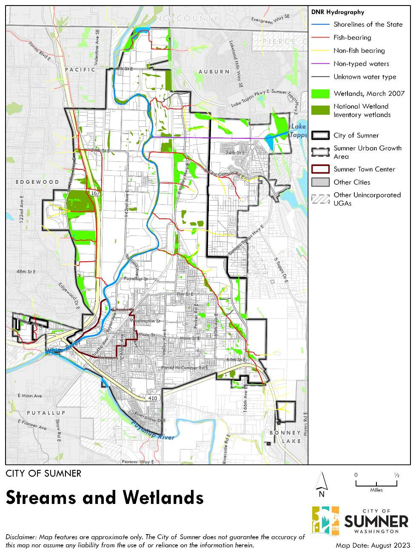
Source: Parametrix November 2023

EXHIBIT B

NON-FISH BEARING STREAMS (TYPE N) LOCATION & CHARACTERISTICS – DRAFT
Source: Sumner GIS layers, Google Earth, Dept. of Natural Resources Stream Types – January 2024

EAST HILLSIDE - Non-Fish Bearing Streams

Segment Location | Description | Landslide Hazard Area* | Wetlands | Development  in City limits | Ownership | UGA (County = 35-115’)
Tributaries to Salmon Creek
1. East of Sumner-Tapps Hwy | Above gravel processing plant | yes | ? | Industrial, quarry site | Private | Forested quarry
2. East of Van Tassel Rd | Within City watershed | yes | yes | Forested watershed | City-owned | x
3. East of Stuck Valley Ave | Within City watershed | yes | ? | Forested watershed | City-owned | x
4. East of E Valley Hwy | Within Puyallup watershed | Yes | yes | Conservation tracts | City & Pierce County | x
Tributaries to White River
5. East of E Valley Hwy at 150th | Forested watershed | Yes | yes | Forested Cava quarry property, watershed | Private, City of Puyallup | 10 SF dwellings
6. East of E Valley Hwy & South of 29th | Forested area below Cava quarry | Yes | yes | SF dwelling | Private | x
7. Along Forest Canyon Rd | Forested hillside | Yes | ? | N/A | N/A | Forested Cava quarry property, 7 SF dwellings
8. E Valley Hwy above Dieringer | Forested hillside | Yes | Yes | Industrial watershed | Private, Cascade Water Alliance | x
9. E Valley at base of hill | Ditch or seeps running N-S betw road & slopes | Yes | ? | 8 SF dwellings | Private | Forested PSE. Water Alliance, PSE

WEST HILLSIDE - Non-Fish Bearing Streams

Segment Location | Description | Landslide Hazard Area* | Wetlands | Development  in City limits | Ownership | UGA
Tributaries to Sotain Creek
1. 37XX W Valley Hwy | Ridgetop industrial development | Yes | No | Warehouses fully developed | Private | x
2. W Valley Hwy | Yusen Logistics wetland | No | Yes | Undeveloped wetland | Private | x
3. W Valley Hwy at 24th St | Neff/Stowe | No | Yes | Grade/fill | Private | x
4. From hillside, crossing W Valley | Industrial site-Cascade Devel | No | No | Industrial/commercial already developed | Private | x

*Landslide hazard areas generally include slopes greater than 15% with fault planes, water seepage, or historic land failures. Geotechnical studies are required for development.
Type I = 25% or greater = Type I Type II = 15-25%
Type I and II: Development limited to 40% of lot area, or 50% for a residential subdivision.

