NOTICE OF REGULAR MEETING CANCELLATION

NOTICE IS HEREBY GIVEN that the City Council of the City of Sumner has cancelled the
October 2nd, 2023, regular council meeting.

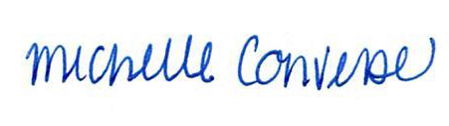
City Clerk Michelle Converse, CMC

Via email 9/19/2023
Website 9/19/2023

