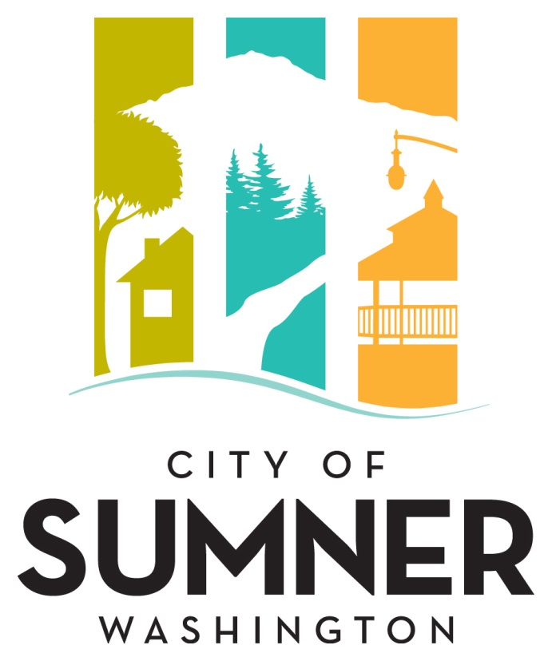

REQUEST FOR QUALIFICATIONS
FOR PROFESSIONAL SERVICES

FOR
BUILDING & FIRE REVIEW & INSPECTION SERVICES

JUNE 2023
CITY OF SUMNER
REQUEST FOR QUALIFICATIONS FOR PROFESSIONAL SERVICES
The City of Sumner solicits interest from consulting firms with expertise in providing professional services in the areas of BUILDING & FIRE REVIEW & INSPECTION SERVICES. At the request of the Jurisdiction services may be provided for Building Official plan review and inspections.

The City of Sumner reserves the right to amend terms of this “Request for Qualifications” (RFQ), to circulate various addenda, or to withdraw the RFQ at any time, regardless of how much time and effort consultants have spent on their responses.

The City of Sumner reserves the right to retain the services of responsive firm(s) for subsequent phases associated with this project.

Introduction

BUILDING & FIRE REVIEW & INPSECTION SERVICES
At the request of the Jurisdiction’s, services will be required to perform the duties as a Building/Fire plans reviewer and inspector.

MEETING ATTENDANCE
The Consultant’s staff is available to attend Jurisdiction requested meetings such as pre-application, pre-construction or cooperative review meetings.

PLAN REVIEW
The Jurisdiction will determine which plans and building permit applications will be reviewed by the Consultant. The Jurisdiction will intake, track, and process the permit applications and all revisions per current building permit administration procedures. The Consultant will review such plans submitted with building permit applications for structural and nonstructural code compliance in accordance with the currently adopted construction codes as adopted and amended by the state of Washington and the Jurisdiction to include the 2018 WA State Fire Code.

BUILDING/FIRE INSPECTION
The Consultant will provide a certified building inspector or equal to perform the following services on an as- needed, on-call basis:
• Upon authorization by the Jurisdiction, the inspector will perform building inspection work for the Jurisdiction.
• The inspector will provide building inspections in accordance with the currently adopted International Codes, Washington State Building Code (WAC 51-50 and 51-11), and Energy Code (WAC 51-11), 2018 WA State Fire Code and the applicable City Building Codes.

Submittal Requirements
The Statement of Qualifications (SOQ) should consist of no more than ten (10) single sided pages covering the below sections. The introductory letter, front and back covers, staff resumes, and section dividers will not be counted in the ten (10) page limit.
- Introduction: Provide a brief introductory letter stating the firm’s interest in the project.
- Discipline: Provide a clear and concise statement of your firm’s specialty or specialties.
- Familiarity with Standards: Provide a concise statement summarizing consultants understanding of applicable City codes and regulations.
- Consultant’s Qualifications: Consultant’s qualifications should include detailed information regarding the key team members and sub-consultants experience on similar projects:

The consultants qualifications should include the following information:
  - Provide brief resumes of no more than four key members of the proposed team.
  - Provide a list of references for similar work experience.

Selection Procedure
After the deadline for acceptance of proposals, the SOQ’s received will be reviewed and evaluated by an Evaluation Committee comprised of, but not limited to, City staff, appointed or elected officials, and individuals chosen by Development Services staff to participate. The Evaluation Committee will rate written proposals based on the evaluation criteria listed below.
The City may choose to interview the top firms as ranked by the Evaluation Committee. Information from interviews i(if needed) along with feedback from references will be incorporated into the final rankings.
If a contract cannot be negotiated with the top ranked firm, the City will contact the next firm in line and attempt to negotiate with that firm. The process will be repeated until an agreement is reached.
Evaluation Criteria
Submittals will be evaluated and ranked based on the following criteria:
- Qualifications/expertise of the firm completing projects of similar complexity and function;
- Qualification of the proposed project manager and key staff members;
- Familiarity with City standards, relevant codes, and City planning requirements; and
- Demonstrated ability of the Consultant to perform high quality work, control costs, meet schedules, prepare documentation, and ensure project commitments are met.

Submittal Deadline:
One (1) electronic copy of the Request for Qualifications shall be delivered by 2:00 p.m. on July 12th, 2023 to the attention of Doug Beagle, Development Services Director, at the following address:
dbeagle@sumnerwa.gov
Any proposal received after the specified date and time may be rejected and not receive any further consideration by the City.
Proposal Contact Person:
All questions regarding this solicitation should be directed to Doug Beagle, Development Services Director, at dbeagle@sumnerwa.gov, 253-299-5715
Americans with Disabilities Act (ADA) Information
This material can be made available in an alternate format by emailing Doug Beagle, Development Services Director, at dougb@sumnerwa.gov, 253-299-5715
Title VI Statement
The City of Sumner in accordance with Title VI of the Civil Rights Act of 1964, 78 Stat. 252, 42 U.S.C. 2000d to 2000d-4 and Title 49, Code of Federal Regulations, Department of Transportation, subtitle A, Office of the Secretary, Part 21, nondiscrimination in federally assisted programs of the Department of Transportation issued pursuant to such Act, hereby notifies all bidders that it will affirmatively ensure that in any contract entered into pursuant to this advertisement, disadvantaged business enterprises as defined at 49 CFR Part 26 will be afforded full opportunity to submit bids in response to this invitation and will not be discriminated against on the grounds of race, color, national origin, or sex in consideration for an award.
Dates of Publication:
Published in the Courier Herald, June 21st, 2023.

