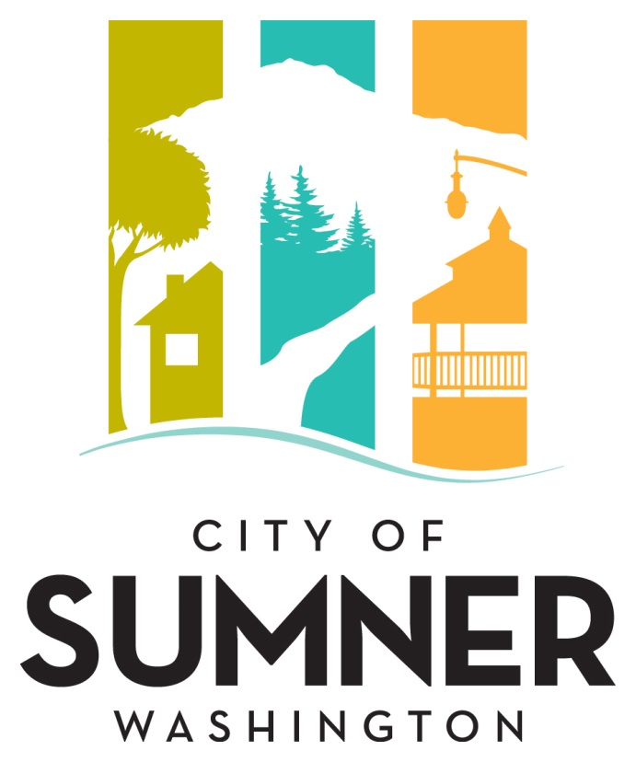

REQUEST FOR QUALIFICATIONS
FOR PROFESSIONAL SERVICES

FOR

CIP 23-08, SYSTEMIC HORIZONTAL CURVE IMPROVEMENTS, FEDERAL AID NO. HSIP-000S (668)

OCTOBER 2023
CITY OF SUMNER
REQUEST FOR QUALIFICATIONS FOR PROFESSIONAL SERVICES
FOR CIP 23-08, SYTEMIC HORIZONTAL CURVE IMPROVEMENTS,
FEDERAL AID NO. HSIP -000S (668)

The City of Sumner solicits interest from consulting firms with expertise in providing professional services in the area of civil engineering and municipal public works projects. Services are expected to last 1 year with the option for the City of Sumner to extend further for additional time and money if necessary. Consultants will be considered for the following project.

The City of Sumner reserves the right to amend the terms of this “Request for Qualifications” (RFQ), to circulate various addenda, or to withdraw the RFQ at any time, regardless of how much time and effort consultants have spent on their responses.

Prospective consultants will be held to Federal Equal Employment Opportunity (EEO) requirements for federally funded projects and to the Americans with Disabilities Act (ADA) and the Civil Rights Act language adopted by the City of Sumner.
Aspects of this project may be subject to WA State Prevailing Wage rules, filings and requirements.

Project Description
The work to be performed by the consultant consists of preparing engineering design and environmental NEPA permitting for CIP 23-08. The project aims to significantly improve the safety conditions along several key roadway segments, including East Valley Highway, West Valley Highway, Sumner-Tapps Highway/166th Avenue E, and 142nd Avenue E. The proposed improvements include installing static and dynamic curve warning signs, speed feedback signs, centerline and edge line profiled striping, rumble strips, profiled striping, reflective markers on the pavement and roadside objects, channelization, guardrail/roadway shouldering, and street lighting. This project has a 0% DBE goal for the design phase.

The City of Sumner reserves the right to retain the services of responsive firm(s) for subsequent phases (Right-of-Way, Construction) associated with this work, which may require subsequent DBE goals.

Evaluation Criteria
Submittals will be evaluated and ranked based on the following criteria:
- Qualifications/expertise of the firm with public works infrastructure; experience with projects of similar complexity and function.
- Qualifications/expertise of the proposed project manager and key staff members.
- Consultant’s approach to the City’s project as demonstrated in a description of their approach to the work.
- Familiarity with WSDOT/FHWA standards, WSDOT LAG Manual, DBE requirements, City of Sumner standards, relevant codes, and City planning requirements.
- Ability to perform high quality work, control costs, meet schedules, prepare documentation, and ensure project commitments are met.
- Past Performance/References.
- Ability to perform work on subsequent phases and meet subsequent DBE goals if required.

Selection Procedure
After the deadline for acceptance of proposals, the Statement of Qualifications (SOQ) will be reviewed and evaluated by an Evaluation Committee comprised of, but not limited to, City staff, appointed or elected officials, and individuals chosen by Public Works staff to participate. The Evaluation Committee will rate written proposals based on the evaluation criteria listed above.

The City will interview the top firms as ranked by the Evaluation Committee. Information from the interviews along with feedback from references will be incorporated into the final rankings.

If a contract cannot be negotiated with the top ranked firm, the City will contact the next firm in line and attempt to negotiate with that firm. The process will be repeated until an agreement is reached.

Format
The SOQ should describe the composition of the proposed team, the qualifications of the key individuals identified on that team, and the relevant experience of the team on similar projects. Respondents may include subconsultants within their project team.

The Consultant’s SOQ should include the following information:
- The proposal should be accompanied by a brief introductory letter stating your firm’s interest in the project;
- Provide resumes of no more than three (3) key members of the proposed project team inclusive of key subconsultant(s) who will work on this project;
- List projects of similar complexity and magnitude undertaken and completed in the past ten (10) years and provide references and a phone number for each reference;
- Reference projects should list the involvement of proposed project team members for whom resumes have been submitted; and
- Please include a statement of assurance that listed team members, including those of subconsultants, will not be replaced without prior approval of the City.

The SOQ should consist of no more than ten (10) pages. The cover letter, front and back covers, and section dividers will not be counted in the ten (10) page limit.

Submittal Deadline:
Please submit an electronic version of your SOQ in a single .pdf document by email or other electronic means to thil@sumnerwa.gov no later than 2:00 p.m. on November 8, 2023. Hard copy submittals are not required. Any proposal received after the specified date and time may be rejected and may not receive any further consideration by the City. Postmarks will not be accepted. All questions regarding this solicitation should be directed to Thi Le, Engineering Specialist at (253) 299-5718 or thil@sumnerwa.gov.

Americans with Disabilities Act (ADA) Information
The City of Sumner in accordance with Section 504 of the Rehabilitation Act (Section 504) and the Americans with Disabilities Act (ADA), commits to nondiscrimination on the basis of disability, in all of its programs and activities. This material can be made available in an alternate format by emailing Thi Le at thil@sumnerwa.gov or by calling 253-299-5718.

Title VI Statement
The City of Sumner, in accordance with the provisions of Title VI of the Civil Rights Act of 1964 (78 Stat. 252, 42 U.S.C. 2000d to 2000d-4) and the Regulations, hereby notifies all bidders that it will affirmatively ensure that in any contract entered into pursuant to this advertisement, disadvantaged business enterprises will be afforded full and fair opportunity to submit bids in response to this invitation and will not be discriminated against on the grounds of race, color, or national origin in consideration for an award.”

Dates of Publication:
Courier Herald: October 18, 2023
Seattle Daily Journal of Commerce: October 18, 2023

