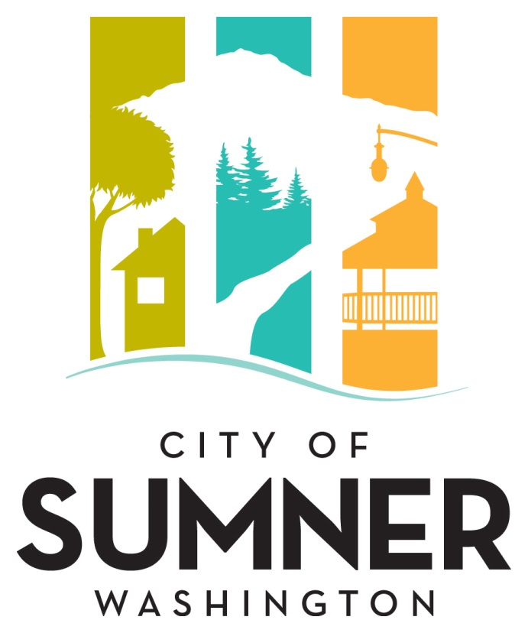

REQUEST FOR QUALIFICATIONS
FOR CONSTRUCTION MANAGEMENT SERVICES FOR THE
SUMNER OPERATIONS FACILITY

NOVEMBER 2023
CITY OF SUMNER
REQUEST FOR QUALIFICATIONS FOR CONSTRUCTION MANAGEMENT SERVICES FOR THE SUMNER OPERATIONS FACILITY

The City of Sumner is seeking Statements of Qualifications from qualified consultants to provide Construction Management Services for the Sumner Operations Facility project to include construction management services, construction inspection, construction administration/document control, procurement of owner furnished equipment and furnishings, commissioning, and special inspections.

The City of Sumner reserves the right to amend terms of this “Request for Qualifications” (RFQ), to circulate various addenda, or to withdraw the RFQ at any time, regardless of how much time and effort consultants have spent on their responses.

Prospective consultants will be held to the ADA and Civil Rights requirements as adopted by the City of Sumner.

Aspects of this project may be subject to WA State Prevailing Wage rules, filings, and requirements.

Consultants will be considered for the following project:

PROJECT BACKGROUND:
The City of Sumner is constructing a new Operations Facility to support the staff and equipment for Public Works and Parks. This project will construct a public works facility with approximately 88,000 sf of total building space over 7 buildings on a 7.6 Acre site. The facility will include an administration building, vehicle storage, fleet washing, material storage and a decant facility. The project will include frontage improvements, landscaping, site lighting, utilities, and stormwater management. The total work is estimated to cost approximately $34 million, is expected to go to ad in Quarter 1 2024 and be complete in early 2026. This is a Design – Bid – Build project. There is no DBE goal for this project. This project is funded locally; no grants or federal funds will be utilized for this project.

More information on the project can be found at the City’s community engagement website:
https://connects.sumnerwa.gov/new-shops-facility

EXPECTED TASKS:
The City is seeking a full suite of Construction Management, Construction Inspection, and Construction Administration/Document Control. The following tasks are examples of some that are expected of the consultant:
- Lead weekly meetings with the City, contractor, and engineer.
- Change management.
- Risk management.
- Contractor schedule review and coordination.
- Track and review contractor RFIs and submittals, coordinate responses.
- Prepare/maintain documentation including: inspection logs, daily reports, force accounts, material testing, pay estimates, serial letters, pre-construction and daily photo documentation, and meeting notes.
- Monthly Pay Estimates.
- Force account tracking and pricing.
- Ensure contractor is utilizing and maintaining Temporary Erosion and Sediment Control (TESC) best practices.
- Inspecting and ensuring the project red-lines/record drawings are up to date.
- Identifying and tracking construction quality issues and problems and recommending potential solutions.
- Monitor deliveries of material for quantities and acceptance criteria.
- Use of cloud-based document control filing that will be accessible to the City.

CONSULTANT QUALIFICATION
The Statement of Qualifications (SOQ) should describe the composition of the proposed team, the qualifications of the key individuals identified on that team, and the relevant experience of the team on similar projects.

The SOQ should:
- Include resumes for key staff to include experience with construction methods used on this project;
- Detail the team’s experience in managing at least three (3) similar type projects;
- Demonstrate experience managing contractor payments, estimating and drafting change orders, contractor schedule review, protests and claims, and processing submittals and RFIs;
- Demonstrate familiarity with construction methods being used on this project, City of Sumner Standards and Development Specifications, and AIA specifications; and
- Include no less than three (3) Past Performance references.

Respondents may include sub-consultants within their project team.

EVALUATION CRITERIA
Submittals will be evaluated and ranked based on the following criteria:
- Qualification/Expertise of Key Staff Members;
- Qualifications/Expertise of Firm;
- Explanation of understanding and approach to the project described above;
- Familiarity with construction methods and standards;
- Past Performance/References; and
- Compliance with the submittal requirements below.

SUBMITTAL
Submittals must include the following information: Firm name and contact information, name of project lead and key staff, and number of employees in each firm proposed to the project. The submittal shall not exceed a total of 15 pages, including cover letter(s) and title page(s). Resumes will not be counted towards the maximum page count.
Please submit an electronic version of your SOQ in a single .pdf document by email or other electronic means to drewm@sumnerwa.gov no later than 2:00 p.m. on November 28th, 2023. Hard copy submittals are not required. Submittals will not be accepted after that time and date. Postmarks will not be accepted to prove deadline satisfaction for submittals that are not in the City’s possession. Consultant is responsible for ensuring SOQ was received. Any questions regarding this project should be directed to Drew McCarty at (253) 299-5719.

Americans with Disabilities Act (ADA) Information
The City of Sumner in accordance with Section 504 of the Rehabilitation Act (Section 504) and the Americans with Disabilities Act (ADA), commits to nondiscrimination on the basis of disability, in all of its programs and activities. This material can be made available in an alternate format by emailing Drew McCarty at drewm@sumnerwa.gov or by calling 253-299-5719.

Title VI Statement
“The City of Sumner, in accordance with the provisions of Title VI of the Civil Rights Act of 1964 (78 Stat. 252,42 U.S.C. 2000d to 2000d-4) and the Federal Regulations, hereby notifies all bidders that will affirmatively ensure that any contract entered into pursuant to this advertisement, disadvantaged business enterprises will be afforded full and fair opportunity to submit bids in response to this invitation and will not be discriminated against on the grounds of race, color, or national origin in consideration for an award.”

Dates of Publication:
Courier Herald: November 8th, 2023
Seattle Daily Journal of Commerce: November 8th, 2023

