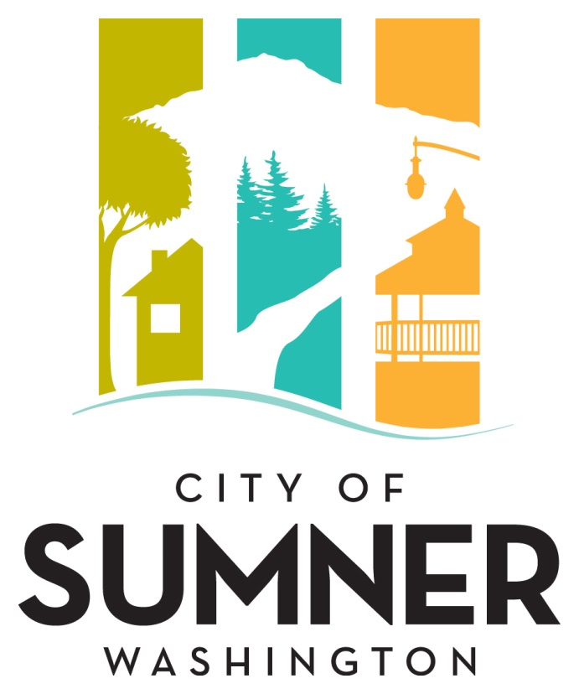

**REQUEST FOR QUALIFICATIONS**

**FOR PROFESSIONAL SERVICES**

**FOR**

**2025 COMPREHENSIVE PLAN UPDATE - CLIMATE PALNNING**

**JUNE 2024**

**CITY OF SUMNER**

**REQUEST FOR QUALIFICATIONS FOR PROFESSIONAL SERVICES**

**FOR 2025 COMPREHENSIVE PLAN UPDATE – CLIMATE PLANNING**

The City of Sumner solicits interest from consulting firms with expertise in providing professional services in the area of environment planning, regulatory compliance, and sustainable urban development projects. Services are expected to last one (1) year with the option for the City of Sumner to extend for additional time and money if necessary. Consultants will be considered for the project described below.

The City of Sumner reserves the right to amend the terms of this “Request for Qualifications” (RFQ), to circulate various addenda, or to withdraw the RFQ at any time, regardless of how much time and effort consultants have spent on their responses.

The consulting team and individuals must have knowledge and formal education in planning and associated disciplines and demonstrated experience and skills in Washington Growth Management Act (GMA) planning and climate response.

Aspects of this project may be subject to WA State Prevailing Wage rules, filings and requirements.

**Project Description**

The work to be performed by the consultant consists of preparing a comprehensive plan and updating the City’s development regulations to address climate response (Washington House Bill 1181). The consultant will review relevant provisions of State law, the Washington Administrative Code, and Washington State Department of Commerce publications when addressing items in the scope of work. The consultant will also review recent City policies and actions responding to HB 1181 in the 2024 Periodic Update to the City’s Comprehensive Plan as required by the Growth Management Act.

Key deliverables include a Vehicle Miles Traveled (VMT) and Greenhouse Gas (GHG) Reduction Action Plan to help decrease emissions and improve air quality, a major update to the ADA Transition Plan to ensure accessibility compliance and enhancements, a Climate Vulnerability Assessment Report for the City Water System Plan to identify and mitigate risks associated with climate change, a detailed Tree Canopy Assessment Report to support urban forestry management and increase green spaces, and the development of policy updates and code revisions to integrate these findings and actions into the City’s regulatory framework.

**Evaluation Criteria**

Submittals will be evaluated and ranked based on the following criteria:

1. Qualifications/expertise of the firm with community development planning infrastructure; experience with projects of similar complexity and function.
2. Qualifications/expertise of the proposed project manager and key staff members
3. Consultant’s approach to the City’s project as demonstrated in a description of their approach to the work.
4. Familiarity with Growth Management Act (GMA), Americans with Disabilities Act (ADA), Climate Change, City of Sumner standards, relevant codes, and City planning requirements.
5. Ability to perform high quality work, control costs, meet schedules, prepare documentation, and ensure project commitments are met.
6. Past Performance/References.

**Selection Procedure**

After the deadline for acceptance of proposals, the Statement of Qualifications (SOQ) will be reviewed and evaluated by an Evaluation Committee comprised of, but not limited to, City staff, appointed or elected officials, and individuals chosen by City of Sumner staff to participate. The Evaluation Committee will rate written proposals based on the evaluation criteria listed above.

The City will interview the top firms as ranked by the Evaluation Committee. Information from the interviews along with feedback from references will be incorporated into the final rankings.

If a contract cannot be negotiated with the top ranked firm, the City will contact the next firm in line and attempt to negotiate with that firm. The process will be repeated until an agreement is reached.

**Format**

The SOQ should describe the composition of the proposed team, the qualifications of the key individuals identified on that team, and the relevant experience of the team on similar projects. Respondents may include subconsultants within their project team.

The Consultant’s SOQ should include the following information:

1. The proposal should be accompanied by a brief introductory letter stating your firm’s interest in the project;
2. Provide resumes of no more than three (3) key members of the proposed project team inclusive of key subconsultant(s) who will work on this project;
3. List projects of similar complexity and magnitude undertaken and completed in the past ten (10) years and provide references and a phone number for each reference;
4. Reference projects should list the involvement of proposed project team members for whom resumes have been submitted; and
5. Please include a statement of assurance that listed team members, including those of subconsultants, will not be replaced without prior approval of the City.

The SOQ should consist of no more than ten (10) pages. The cover letter, front and back covers, and section dividers will not be counted in the ten (10) page limit.

**Submittal Deadline:**

Please submit an electronic version of your Statement of Qualifications in a single .pdf document by email or other electronic means to [thil@sumnerwa.gov](mailto:thil@sumnerwa.gov) no later than 2:00 p.m. on August 14, 2024. Hard copy submittals are not required. Any proposal received after the specified date and time may be rejected and may not receive any further consideration by the City. Postmarks will not be accepted. All questions regarding this solicitation should be directed to Thi Le, Engineering Specialist at (253) 299-5718 or [thil@sumnerwa.gov](mailto:thil@sumnerwa.gov).

**Americans with Disabilities Act (ADA) Information**

The City of Sumner in accordance with Section 504 of the Rehabilitation Act and the Americans with Disabilities Act (ADA), commits to nondiscrimination on the basis of disability, in all of its programs and activities. This material can be made available in an alternate format by emailing Thi Le at [thil@sumnerwa.gov](mailto:thil@sumnerwa.gov) or by calling 253-299-5718.

**Title VI Statement**

The City of Sumner, in accordance with the provisions of Title VI of the Civil Rights Act of 1964 (78 Stat. 252, 42 U.S.C. 2000d to 2000d-4) and the Regulations, hereby notifies all bidders that it will affirmatively ensure that in any contract entered into pursuant to this advertisement, disadvantaged business enterprises will be afforded full and fair opportunity to submit bids in response to this invitation and will not be discriminated against on the grounds of race, color, or national origin in consideration for an award.”

**Dates of Publication:**

Courier Herald: July 24 and 31, 2024

Seattle Daily Journal of Commerce: July 24 and 31, 2024