

**NOTICE OF SUMNER CITY COUNCIL SPECIAL STUDY SESSIONS**

**NOTICE IS HEREBY GIVEN** that the City Council of the City of Sumner has scheduled the following special budget study session meetings in September:

**September 3, 2024 at 6:15pm**

* Public Works Operations Financing
* Community Partner Fund

**September 16, 2024 at 6:15pm**

* Legislative
* Executive
* Finance
* Legal
* Court
* Human Resources
* Development Services
* Police Department / Drug Fund

**September 18, 2024 from 12-5pm**

* Street Operations
* Sidewalks
* Streets Capital
* Water
* Sewer
* Waste Water Treatment Facility
* Storm
* Capital Projects

**September 30, 2024 at 6:00pm**

* Parks
* Cemetery
* Parks Capital
* Facilities
* Facilities Capital

Meeting agenda packets including the Zoom links will be available on the City’s website, by 5pm, the Wednesday prior to the meeting date.

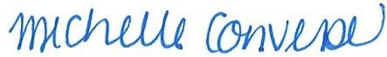 Michelle Converse, City Clerk

Posted/emailed August 20, 2024