NOTICE OF THE SUMNER CITY COUNCIL

NOTICE IS HEREBY GIVEN that the City of Sumner Council has fixed Tuesday,
October 22, 2024, beginning at 5pm as the time to participate in the City of Sumner Open House at City Hall, 1104 Maple Street, Sumner, WA 98390.

A quorum of the City Councilmembers is expected to be present for this event. This is not a business meeting of the Council, and no action will be taken.

NOTICE IS HEREBY GIVEN that the City of Sumner City Council has fixed Friday,
October 25, 2023, at 4:30pm as the time to participate in the Sumner High School Homecoming Parade.

A quorum of the City Councilmembers is expected to be present for this event. This is not a business meeting of the Council, and no action will be taken.

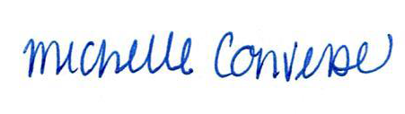
City Clerk Michelle Converse, CMC

Posted October 22, 2024

