NOTICE OF THE SUMNER CITY COUNCIL

NOTICE IS HEREBY GIVEN the Sumner City Council has fixed Wednesday,
October 30, 2024, beginning at 2pm, as the time to participate in a ribbon cutting ceremony at the intersection of Wood Avenue and Main Street.
.
A quorum of the City Councilmembers is expected to be present for this event. This is not a business meeting of the Council, and no action will be taken.

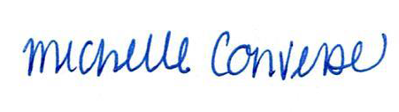
City Clerk Michelle Converse, CMC

emailed & posted October 23, 2024

