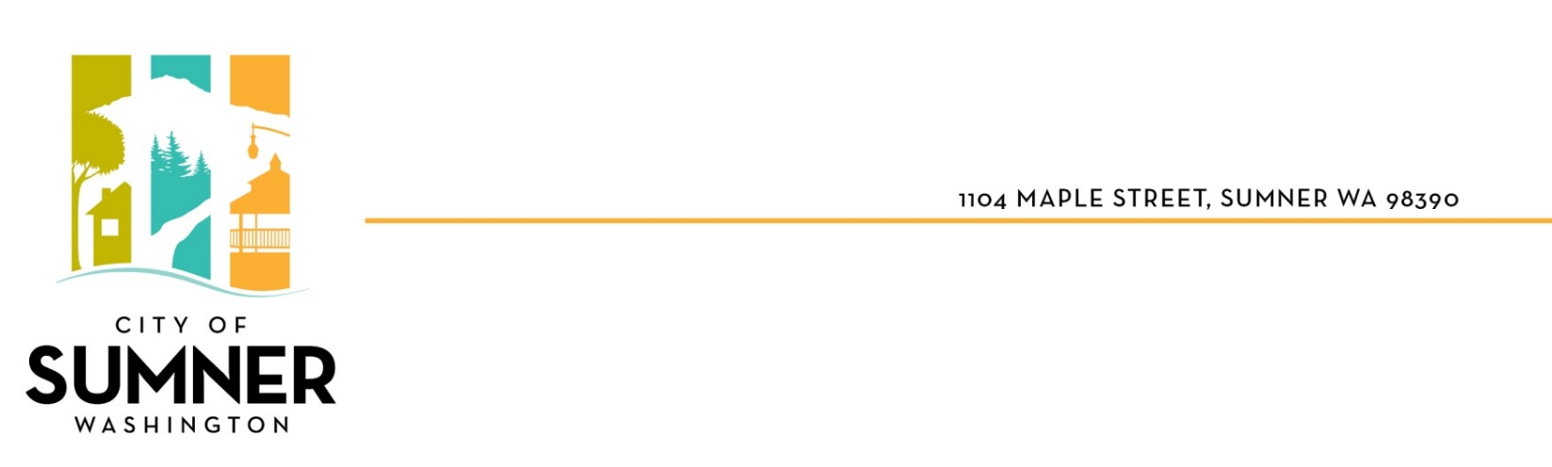
STAFF REPORT

DATE: December 2, 2024
TO: SUMNER CITY COUNCIL
FROM: Ryan Windish, Director of Economic and Community Development
RE: Zoning Code Text Amendment – Historic & Cultural Resource Regulations
File #: CTA-2024-0002

I. BACKGROUND

Purpose: The City Council is being asked to take action on Ordinance No. 2908, for the 2024 Comprehensive Plan Historic & Cultural Resource Regulations

Why amendments are being proposed

The State Growth Management Act (GMA) requires cities to complete a “10-year periodic update” of their Comprehensive Plans. Sumner’s 10-year update will involve extensive revisions to the Comprehensive Plan and regulations to reflect new State laws and changes that have occurred over the last decade.

The GMA lists Historic Preservation as one of its many planning goals: “Identify and encourage the preservation of lands, sites, and structures, that have historical or archaeological significance” (RCW 36.70A.020). The GMA does not require that cities adopt specific regulations to protect historic/cultural resources. However, policies proposed in the 2024 Sumner Comprehensive Plan are intended to strengthen and promote the review, consideration and avoidance of potential impacts to historic/cultural resources. New regulations are proposed to implement these policies.

The Planning Commission reviewed the proposed amendments, along with other 2024 Comprehensive Plan and regulation updates, in August and September 2023, and June 2024. The Commission held a public hearing on the Plan and regulations on April 4, 2024.

II. SUMMARY OF PROPOSAL

The proposed amendments to Sumner Municipal Code Title 18 Zoning Code will update regulations related to protection of historic and cultural resources. Currently, the City does not have historic preservation regulations. Key changes include:

      - New regulations apply only to Town Center Plan area (i.e. downtown) (see Exhibit A).

- Add a requirement that applicants proposing a demolition of structures more than 45 years old, or significant new construction in the Town Center Plan area, must request a consultation with the State Department of Archeology and Historic Preservation (DAHP). Projects would not be considered “significant” if exempt from SEPA environmental review (e.g. a new porch, minor repairs, window replacement, etc.).

- Add a requirement that DAHP’s recommended mitigation measures (if received within 30 days) must be considered and implemented only if appropriate to the site/project. The 30-day timeline corresponds to DAHP’s typical review process.

- Require Inadvertent Human Remains Discovery Language to be included in permits; require provisions in permits to immediately stop work and notify appropriate agencies if artifacts are uncovered during site work.

III. ANALYSIS

Sumner code requires that proposals to amend the Zoning Code include an explanation of how the proposed amendments implement the comprehensive plan (SMC 18.56.149(C)(2)). Relevant sections and policies related to the proposed text amendments are presented below.

HISTORIC ELEMENT

Goal 1. Identify, preserve, and enhance the historic and prehistoric cultural resources of Sumner.
1.2 Through the environmental review process, consider potential impacts to archaeological resources.
1.4 Coordinate with community organizations, property owners and local citizens to protect, acquire, and/or restore key historic properties.

Goal 3. Recognize the heart and historic meaning of Downtown. 3.1 Ensure Downtown’s historic character is retained as new businesses and buildings are established, such as through design standards, historic preservation ordinances, or other means.
3.1 Ensure Downtown’s historic character is retained as new businesses and buildings are established, such as through design standards, historic preservation ordinances, or other means.

ECONOMIC DEVELOPMENT ELEMENT

Goal 5. Promote downtown as the town’s cultural, historic and activity center of the entire community.

COMMUNIY CHARACTER ELEMENT

1.5 Encourage in the community a continuous commitment to maintaining Sumner's character and quality of place, including land conservation and stewardship, wise management of streetscapes and public viewsheds, property maintenance, and historic preservation.
3.20 Adopt a “form-based code” in the Town Center to ensure that the design standards for multi-family and mixed use development are specific enough to create high quality designs and were appropriate to be compatible with the historic architectural context, and scale of Main Street.
5.1 In reviewing plans and development proposals, consider both long and short term environmental impacts and encourage design which complements the area's natural and cultural features. Natural and significant cultural features should be integrated into the design of the community.
6.1 Promote a compact development pattern that exhibits variety in building types and scale. Historic and vernacular architectural styles should be respected. Both sides of the streetscape should complement each other.

CONCLUSION:
The amendments would make Sumner’s regulations consistent with State guidelines for the protection of historic and cultural resources. The amendments, overall, are consistent with the goals and policies related to historic preservation within the City’s Comprehensive Plan, including the policies discussed above. Additional analysis is contained in the Draft Environmental Impact Statement for the 2024 Comprehensive Plan (Volume II), issued March 1, 2024.

IV. PUBLIC & AGENCY COMMENTS

The public notice for the Draft Comprehensive Plan and Draft EIS was issued March 1, 2024, with a public comment period from March 1 to April 30, 2024. An additional 15-day notice of the Planning Commission public hearing was published on March 12. Comments received were forwarded to the Planning Commission prior to final recommendations

V. SEPA ENVIRONMENTAL REVIEW

The State Environmental Policy Act (SEPA) establishes a process for SEPA review of Comprehensive Plan and regulations updates. In compliance with State SEPA environmental regulations, the 2024 Draft Comprehensive Plan (Volume I) and Draft Environmental Impact Statement for the 2024 Comprehensive Plan (Volume II) were issued March 1, 2024 for public review through April 30, 2024. The EIS consists of an evaluation of the potential impacts of proposed policy and regulation changes, and is available for review on the City’s website at: https://connects.sumnerwa.gov/planning-sumners-future.

VI. PLANNING COMMISSION RECOMMENDATION

The Planning Commission voted unanimously to recommend that the City Council “Move to approve of Ordinance No. 2908 for the 2024 Comprehensive Plan Historic and Cultural Resources Regulations dated September 25, 2024.”

VII. EXHIBITS & REFERENCES

- Ordinance No. 2908: Historic and Cultural Resources Regulations dated September 25, 2024

EXHIBIT A
Town Center Plan Boundary (area where code applies) for reference only
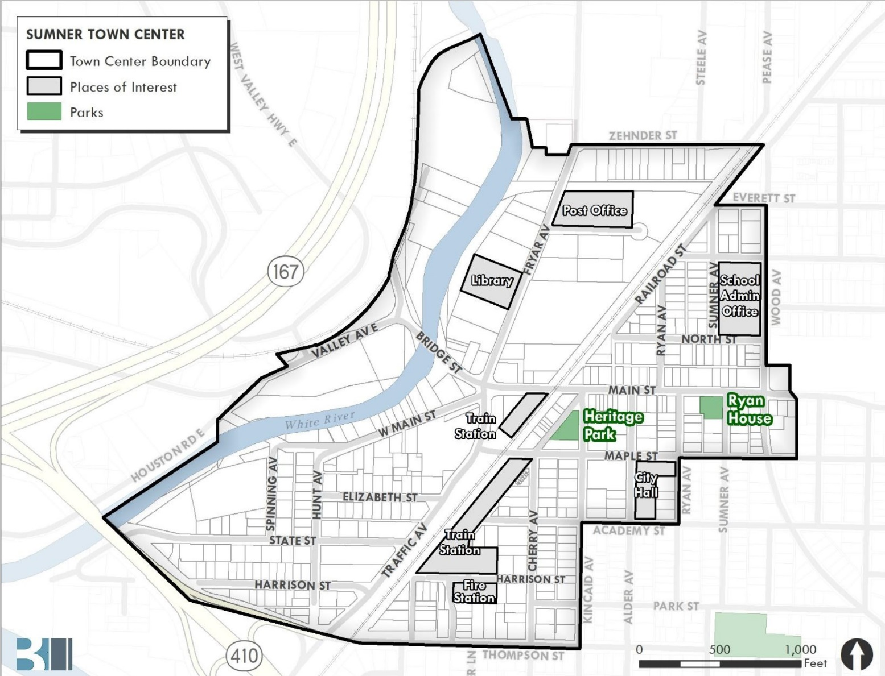
Source: Town Center Plan adopting ordinance 2018

