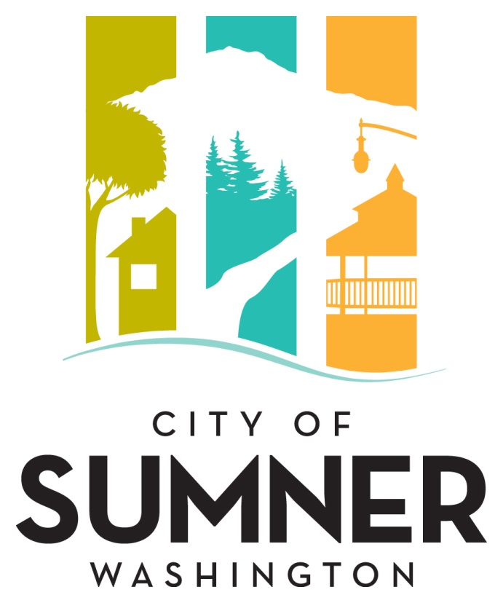

**REQUEST FOR QUALIFICATIONS**

**FOR PROFESSIONAL SERVICES**

**FOR**

**UTILITY RATE STUDY**

**January 2025**

**CITY OF SUMNER**

**REQUEST FOR QUALIFICATIONS FOR PROFESSIONAL SERVICES**

**FOR UTILITY RATE STUDY**

The City of Sumner solicits interest from consulting firms with expertise in providing professional services in the area of municipal financial analysis.  Services are anticipated to be completed within the 2025 calendar year.

The City of Sumner reserves the right to retain the services of responsive firm(s) for subsequent phases associated with this work.

The City of Sumner reserves the right to amend terms of this “Request for Qualifications” (RFQ), to circulate various addenda, or to withdraw the RFQ at any time, regardless of how much time and effort consultants have spent on their responses.

Prospective consultants will be held to Federal EEO requirements for federally funded projects and to the ADA and Civil Rights language adopted by the City of Sumner.

**Project Description**

The City of Sumner is seeking professional services for financial analysis of its Water, Wastewater, and Storm Water utilities. The goal of this study is to prepare recommendations for the City Council’s adoption of utility rates and fees necessary to provide operational and capital funding for each of the City’s three utilities.

**Evaluation Criteria**

Submittals will be evaluated and ranked based on the following criteria:

1. Qualification of the proposed project manager and key staff members;
2. Qualifications/expertise of the firm with the utility and public works infrastructure in the area; experience with projects of similar complexity and function.
3. Consultant’s approach to the City’s project as demonstrated in a description of their approach to the work;
4. Familiarity with City standards, relevant codes, and City planning requirements; and
5. Demonstrated ability of the Consultant to perform high quality work, control costs, meet schedules, prepare documentation, and ensure project commitments are met.

**Selection Procedure**

After the deadline for acceptance of proposals, the SOQ’s will be reviewed and evaluated by an Evaluation Committee comprised of, but not limited to, City staff, appointed or elected officials, and individuals chosen by Public Works staff to participate. The Evaluation Committee will rate written proposals based on the evaluation criteria listed above.

The City may choose to interview the top firms as ranked by the Evaluation Committee. Information from the interviews along with feedback from references will be incorporated into the final rankings.

If a contract cannot be negotiated with the top ranked firm, the City will contact the next firm in line and attempt to negotiate with that firm. The process will be repeated until an agreement is reached.

**Format**

The Statement of Qualifications (SOQ) should describe the composition of the proposed team, the qualifications of the key individuals identified on that team, and the relevant experience of the team on similar projects. Respondents may include subconsultants within their project team.

The Consultant’s Statement of Qualifications should include the following information:

1. The proposal should be accompanied by a brief introductory letter stating your firm’s interest in the project.
2. Provide resumes of no more than three (3) key members of the proposed project team inclusive of key subconsultant who will work on this project.
3. List projects of similar complexity and magnitude undertaken and completed in the past ten (10) years and provide references and a phone number for each reference.
4. Reference projects should list the involvement of proposed project team members for whom resumes have been submitted.
5. Please include a statement of assurance that listed team members, including those of subconsultants, will not be replaced without prior approval of the City.

The Statement of Qualifications (SOQ) should consist of no more than ten (10) pages. The cover letter, front and back covers, and section dividers will not be counted in the ten (10) page limit.

**Submittal Deadline:**

Please submit an electronic version of your Statement of Qualifications in a single .pdf document by email or other electronic means to thil@sumnerwa.gov and drewm@sumnerwa.gov no later than no later than **11:00 a.m. on February 7th, 2025**. Hard copy submittals are not required. Any proposal received after the specified date and time may be rejected and may not receive any further consideration by the City. Postmarks will not be accepted. All questions regarding this solicitation should be directed to Thi Le, Engineering Specialist at (253) 299-5718 or [thil@sumnerwa.gov](mailto:thil@sumnerwa.gov).

**Americans with Disabilities Act (ADA) Information**

The City of Sumner in accordance with Section 504 of the Rehabilitation Act (Section 504) and the Americans with Disabilities Act (ADA), commits to nondiscrimination on the basis of disability, in all of its programs and activities. This material can be made available in an alternate format by emailing the Contact person or by calling collect 253-299-5700.

**Title VI Statement**

The City of Sumner in accordance with Title VI of the Civil Rights Act of 1964, 78 Stat. 252, 42 U.S.C. 2000d to 2000d-4 and Title 49, Code of Federal Regulations, Department of Transportation, subtitle A, Office of the Secretary, Part 21, nondiscrimination in federally assisted programs of the Department of Transportation issued pursuant to such Act, hereby notifies all bidders that it will affirmatively ensure that in any contract entered into pursuant to this advertisement, disadvantaged business enterprises as defined at 49 CFR Part 26 will be afforded full opportunity to submit bids in response to this invitation and will not be discriminated against on the grounds of race, color, national origin, or sex in consideration for an award.

**Federal Emergency Management Agency Assurances**

Agencies shall read and document that they will comply with the assurances and certifications contained in FEMA Form 20-16A, Assurances - Nonconstruction Programs; FEMA Form 20-16B, Assurances-Construction Programs; FEMA Form 20-16C, Certifications Regarding Lobbying; Debarment, Suspension, and Other Responsibility Matters; and Drug-Free Workplace Requirements; SF LLL, Disclosure of Lobbying Activities (If applicable). Agencies shall further agree that they will include the clause title “Certification Regarding Debarment, Suspension, Ineligibility and Voluntary Exclusion-Lower Tier Covered Transaction,” provided by the FEMA Regional Office, without modification, in all lower tier covered transactions and in all solicitations for lower tier covered transactions. (Refer to 44 CFR Part 17.)

**Dates of Publication:**

Courier Herald: January 8 and January 15, 2025

Seattle Daily Journal of Commerce: January 8 and January 15, 2025