NOTICE OF THE SUMNER CITY COUNCIL – MARCH 2025

NOTICE IS HEREBY GIVEN that the City of Sumner City Council has fixed Monday,
March 3, 2025, beginning at 4pm as the time to participate in the groundbreaking for the City of Sumner’s Public Works Operations Facility, located at the facility site on 29th Street East, Sumner.

A quorum of the City Councilmembers is expected to be present for this event. This is not a business meeting of the Council, and no action will be taken.

NOTICE IS HEREBY GIVEN that the City of Sumner City Council has fixed Thursday,
March 13, 2025, to participate in the Sumner-Bonney Lake Community for Families 2025 Community Summit. This event will be held at Calvary Community Church, 15116 Gary Street East; Sumner, 98390. Check-in for the event begins at 4:00pm.

A quorum of the City Councilmembers is expected to be present for this event. This is not a business meeting of the Council, and no action will be taken.

NOTICE IS HEREBY GIVEN that the City of Sumner City Council has fixed Tuesday,
March 18, 2025, beginning at 10:30am as the time to participate in the start of the Stewart Road bridge replacement, located at the bridge along Stewart Road.

A quorum of the City Councilmembers is expected to be present for this event. This is not a business meeting of the Council, and no action will be taken.

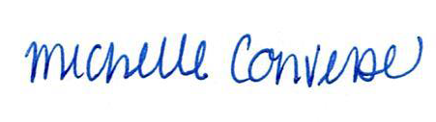
City Clerk Michelle Converse, CMC

emailed & posted February 13, 2025

