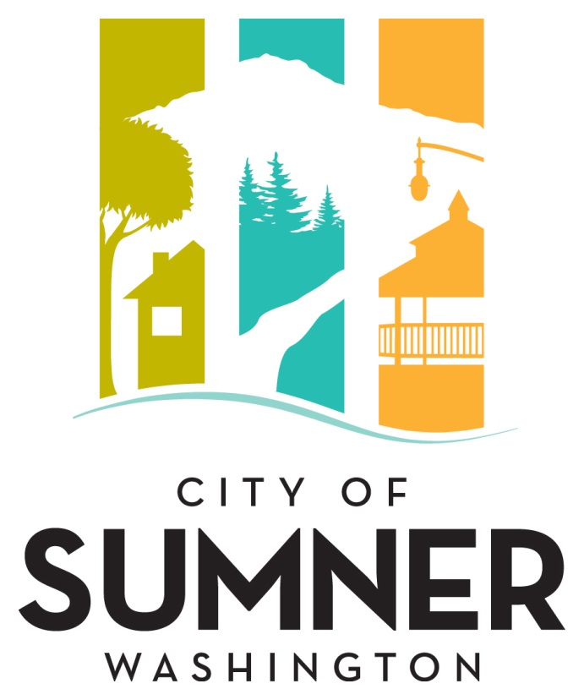

**REQUEST FOR QUALIFICATIONS**

**FOR PROFESSIONAL SERVICES**

**FOR**

**Structural and Non-Structural Plan Review**

**February 2025**

**CITY OF SUMNER**

**REQUEST FOR QUALIFICATIONS FOR PROFESSIONAL SERVICES**

**FOR**

**Structural & Non-Structural Plan Review**

The City of Sumner solicits interest from consulting firms with expertise in providing professional services in Structural and Non- Structural Plan Review for the City’s Development Services Department.

The City of Sumner reserves the right to retain the services of responsive firm(s) for subsequent phases associated with this work.

The City of Sumner reserves the right to amend terms of this “Request for Qualifications” (RFQ), to circulate various addenda, or to withdraw the RFQ at any time, regardless of how much time and effort consultants have spent on their responses.

Prospective consultants will be held to Federal EEO requirements for federally funded projects and to the ADA and Civil Rights language adopted by the City of Sumner.

**Project Description**

**OVERVIEW AND PURPOSE**

The City of Sumner Development Services utilizes consultants for structural and non-structural plan review for various types of building permit applications. Plan review services include, but are not limited to building, mechanical, plumbing, medical gas systems, fire systems (including Smoke Control), energy efficiency. Historically, the scope of projects commonly ranges from single family dwellings to six (6) -story commercial buildings and mix use. City zoning now permits high-rise buildings in some areas, so the consultant would be expected to perform structural and/or non-structural review for such projects. The City intends to potentially select and contract with more than one consultant for these services.

**CITY ADOPTED CODES**

Current codes adopted by the City of Sumner: 2021

• International Building Code, 2018 Edition, with State Amendments

• International Residential Code, 2018 Edition, with State Amendments

• Uniform Plumbing Code, 2018 Edition, with State Amendments

• International Mechanical Codes 2018 Edition, with State Amendments

• International Fuel Gas Code, 2018 Edition, with State Amendments

• International Fire Code, 2018 Edition, with State Amendments

• International Existing Building Code, 2018 Edition, with State Amendments

• International Property Maintenance Code, 2018 Edition, with State Amendments

• Washington State Energy Code

• City of Sumner Design Standards (including applicable section amendments to the above noted codes)

The City plans to adopt the International Wildland Urban Interface Code once implemented by Washington State.

**PROJECT SCOPE**

The selected consultant(s) must be versed in structural and/or non-structural plan review of various types of structures.

When the contract is executed the following service (turn around) times will be expected:. Consultants’ turnaround timeline must be within the supplied date by City Staff, with the ability to move projects up in line if requested by the Director or his/her Designee.

**Standard Plan Review Times**

Type of Project First Review Subsequent Reviews

Single Family Dwellings 10 working days 10 working days

Multi-Family Dwellings 28 working days 14 working days

Commercial <100,000 sf 28 working days 14 working days

Com.100,000sf & High-rise 28 working days 14 working days

The consultant(s) must be able to send and receive plans electronically from the City of Sumner and return reviews complete within the prescribed Standard Plan Review Times specified above. The consultant(s) shall perform plan review following receipt of completed project documents and necessary supporting data, as noted in the letter of transmittal from the City. The consultant(s) shall provide notice to the City within 24-hours of receipt of the letter of transmittal and project documents, of any individual circumstance of non-compliance or anticipated difficulty, which may influence performing the plan review.

It is essential that the consultant(s) provide qualified, experienced staff, capable of and devoted to the successful accomplishment of the work performed under the terms and conditions of an awarded contract. The City currently utilizes electronic plan review for all projects using Blue Beam Software.

The consultant(s) shall issue to the City formal written comments in letter format with summary for each set of project documents reviewed. The consultant(s) shall specifically detail elements requiring revision to comply with the City adopted codes and regulations. The consultant(s) shall return project documents to the City for final dispensation.

Review documents should consist of comment letters citing deficiencies and identifying the review as the first, second, or third review. Required Special Inspections and/or deferred submittals shall also be noted on the comment letter. All final review documents should be marked accordingly to indicate that they have been approved for release pending City approval.

When requested by City staff, the consultant will meet with City staff and other interested parties to conduct one or more preliminary assessment of projects proposed to be submitted to the City for permit. These meetings will be used to allow the City staff and consultant to become familiar with the proposed project and ascertain any major issues that may be present. On occasion, consultant(s) may also be requested to attend an initial Pre-application meeting with City staff and representatives of the project. Such meetings will be based on an hourly rate as mutually agreed to at the acceptance of the proposal and execution of agreement and will last no longer than two hours each. Location will be determined through mutual agreement of all parties, but typically at City Hall or virtually via video conferencing.

Telephonically, virtually or in person provide verbal and/or written technical construction code assistance to City staff regarding projects under review or construction in the City, when requested.

Consultant(s) may be required to perform services in addition to those described above, and the City will compensate the consultant(s) by hourly charges as mutually agreed to at the acceptance of the proposal and execution of agreement.

Any questions must be submitted by email to the City’s Development Services Coordinator at: [allisonj@sumnerwa.gov](mailto:allisonj@sumnerwa.gov)

**Evaluation Criteria**

Submittals will be evaluated and ranked based on the following criteria:

1. Qualification of the proposed project manager and key staff members;
2. Qualifications/expertise of the firm with the utility and public works infrastructure in the area; experience with projects of similar complexity and function.
3. Consultant’s approach to the City’s project as demonstrated in a description of their approach to the work;
4. Familiarity with City standards, relevant codes, and City planning requirements; and
5. Demonstrated ability of the Consultant to perform high quality work, control costs, meet schedules, prepare documentation, and ensure project commitments are met.

**Selection Procedure**

After the deadline for acceptance of proposals, the SOQ’s will be reviewed and evaluated by an Evaluation Committee comprised of, but not limited to, City staff, appointed or elected officials, and individuals chosen by Public Works staff to participate. The Evaluation Committee will rate written proposals based on the evaluation criteria listed above.

The City may choose to interview the top firms as ranked by the Evaluation Committee. Information from the interviews along with feedback from references will be incorporated into the final rankings.

If a contract cannot be negotiated with the top ranked firm, the City will contact the next firm in line and attempt to negotiate with that firm. The process will be repeated until an agreement is reached.

**Format**

The Statement of Qualifications (SOQ) should describe the composition of the proposed team, the qualifications of the key individuals identified on that team, and the relevant experience of the team on similar projects. Respondents may include subconsultants within their project team.

The Consultant’s Statement of Qualifications should include the following information:

1. The proposal should be accompanied by a brief introductory letter stating your firm’s interest in the project.
2. Provide resumes of no more than three (3) key members of the proposed project team inclusive of key subconsultant who will work on this project.
3. List projects of similar complexity and magnitude undertaken and completed in the past ten (10) years and provide references and a phone number for each reference.
4. Reference projects should list the involvement of proposed project team members for whom resumes have been submitted.
5. Please include a statement of assurance that listed team members, including those of subconsultants, will not be replaced without prior approval of the City.

The Statement of Qualifications (SOQ) should consist of no more than ten (10) pages. The cover letter, front and back covers, and section dividers will not be counted in the ten (10) page limit.

**Submittal Deadline:**

Please submit an electronic version of your Statement of Qualifications in a single .pdf document by email or other electronic means to [dbeagle@sumnerwa.gov](mailto:dbeagle@sumnerwa.gov) no later than no later than **11:00 a.m. on March 17th, 2025**. Hard copy submittals are not required. Any proposal received after the specified date and time may be rejected and may not receive any further consideration by the City. Postmarks will not be accepted. All questions regarding this solicitation should be directed to Doug Beagle, Development Services Director (253) 299-5715 or [dbeagle@sumnerwa.gov](mailto:dbeagle@sumnerwa.gov).

**Americans with Disabilities Act (ADA) Information**

The City of Sumner in accordance with Section 504 of the Rehabilitation Act (Section 504) and the Americans with Disabilities Act (ADA), commits to nondiscrimination on the basis of disability, in all of its programs and activities. This material can be made available in an alternate format by emailing the Contact person or by calling collect 253-299-5700.

**Title VI Statement**

The City of Sumner, in accordance with the provisions of Title VI of the Civil Rights

Act of 1964 (78 Stat. 252,42 U.S.C. 2000d to 2000d-4) and the Regulations,

hereby notifies all bidders that will affirmatively ensure that any contract entered

into pursuant to this advertisement, disadvantaged business enterprises will be

afforded full and fair opportunity to submit bids in response to this invitation and

will not be discriminated against on the grounds of race, color, or national origin in

consideration for an award.

**Federal Emergency Management Agency Assurances**

Agencies shall read and document that they will comply with the assurances and certifications contained in FEMA Form 20-16A, Assurances - Nonconstruction Programs; FEMA Form 20-16B, Assurances-Construction Programs; FEMA Form 20-16C, Certifications Regarding Lobbying; Debarment, Suspension, and Other Responsibility Matters; and Drug-Free Workplace Requirements; SF LLL, Disclosure of Lobbying Activities (If applicable). Agencies shall further agree that they will include the clause title “Certification Regarding Debarment, Suspension, Ineligibility and Voluntary Exclusion-Lower Tier Covered Transaction,” provided by the FEMA Regional Office, without modification, in all lower tier covered transactions and in all solicitations for lower tier covered transactions. (Refer to 44 CFR Part 17.)

**Dates of Publication:**

Courier Herald: February 20th and February 27th, 2025

Seattle Daily Journal of Commerce: February 20th and February 27th, 2025