NOTICE OF THE SUMNER CITY COUNCIL

NOTICE IS HEREBY GIVEN that the City of Sumner City Council has fixed Tuesday,
March 25, 2025, as the time and date to participate in the Puyallup/Sumner Chamber of Commerce Economic Forecast Luncheon. This event will be held at The Hansen Place, 823 Main St A; Sumner, 98390. Doors open at 11:15am.

A quorum of the City Councilmembers is expected to be present for this event. This is not a business meeting of the Council, and no action will be taken.

NOTICE IS HEREBY GIVEN that the City of Sumner City Council has fixed Saturday,
April 2, 2025, beginning at 2:30 as the time and date to participate in the Daffodil Grand Floral Parade.

A quorum of the City Councilmembers is expected to be present for this event. This is not a business meeting of the Council, and no action will be taken.

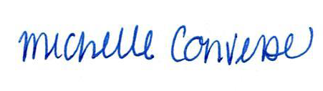
City Clerk Michelle Converse, CMC

emailed & posted March 13, 2025

