**NOTICE OF CANCELLATIONS OF THE SUMNER CITY COUNCIL**

**NOTICE IS HEREBY GIVEN** that the City Council of the City of Sumner has cancelled   
the May 27, 2025, study session and the regularly scheduled Council meeting of June 2, 2025.

**NOTICE OF SPECIAL JOINT STUDY SESSION**

**NOTICE IS HEREBY GIVEN** that the City Council of Sumner has scheduled a special study session on Monday, June 2, 2025, with City Commissions and other invited guests for the purposes of touring the Kenmore Hanger at Town Square located at 6728 NE 181st Street, Kenmore, WA 98028; leaving Sumner City Hall at 1104 Maple Street at 3:30pm and returning at approximately 8:30pm.

If you wish to join during the tour, contact Joseph McKinney, Communications Coordinator at

253-299-5504 for up-to-date locations.

.

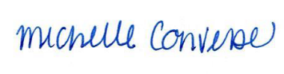

City Clerk Michelle Converse, CMC

Emailed and posted May 19, 2025