NOTICE OF JUNE 2, 2025, MEETING Rev. 1

NOTICE IS HEREBY GIVEN that the City Council of Sumner has scheduled a special joint study session on Monday, June 2, 2025, with the Sumner Planning Commission and Parks & Forestry Commission for the purposes of touring the Kenmore Hanger at Town Square located at 6728 NE 181st Street, Kenmore, WA 98028; leaving Sumner City Hall at 1104 Maple Street at 3:30pm and returning at approximately 9:00pm.

If you wish to join during the tour, contact Communications Coordinator Joseph McKinney at
253-299-5504 Communications Director Carmen Palmer at 253-299-5503 for location updates.

The regularly scheduled Council meeting of June 2, 2025, has been cancelled.

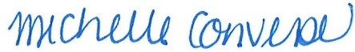

City Clerk Michelle Converse, CMC

Emailed: 5/15/2025
On-line: 5/15/2025
Revised 5/28/2025

