**NOTICE OF THE SUMNER CITY COUNCIL**

**NOTICE IS HEREBY GIVEN** that the City of Sumner City Council has fixed Tuesday,   
August 5th, 2025, as the time and date to participate in the City of Sumner Annual All-Staff BBQ. This event will be held west of the Wastewater Treatment Facility from 11:30am-1:00pm.

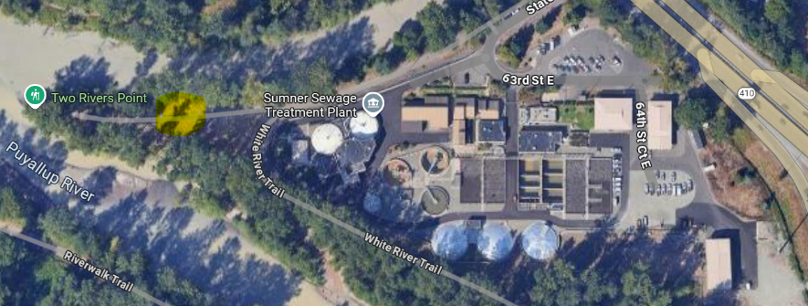

A quorum of the City Councilmembers is expected to be present for this event. This is not a business meeting of the Council, and no action will be taken.

City Clerk Michelle Converse, CMC

*emailed & posted July 10, 2025*