NOTICE OF THE SUMNER CITY COUNCIL

**RESOLUTION NO. 1728**

**A RESOLUTION OF THE CITY COUNCIL OF THE CITY OF SUMNER,**

**WASHINGTON, SETTING THE PUBLIC HEARING DATE WITH REGARD TO COUNCIL ASSUMING LEADERSHIP OF THE SUMNER TRANSPORTATION BENEFIT DISTRICT (TBD).**

**WHEREAS**, the City Council instructed staff to pursue forming and funding a TBD in Sumner to help consistently fund road maintenance and preservation; and

**WHEREAS**, the second step of forming a TBD as outlined by State law is to consider the City Council assuming all of the TBD's rights, powers, functions, and obligations, with the result that the TBD ceases to exist as a separate legal entity; and

**WHEREAS**, RCW 36.74.020-.030 requires councils to hold a public hearing before assuming a TBD’s leadership.

**NOW, THEREFORE, THE CITY COUNCIL OF THE CITY OF SUMNER, WASHINGTON DOES RESOLVE AS FOLLOWS:**

**Section 1**. That Monday, August 4, 2025, at approximately 6:00pm, in the Council Chambers in the City Hall at 1104 Maple Street, Sumner, Washington, will be the time and place for a public hearing to receive public comment on assuming leadership of a Transportation Benefit District (TBD). Written comments must be submitted by 4pm the day of the hearing to the City Clerk, Michelle Converse at [michellec@sumnerwa.gov.](mailto:michellec@sumnerwa.gov)

**Section 2. Corrections by City Clerk or Code Reviser.** Upon approval of the city attorney, the city clerk and the code reviser are authorized to make necessary corrections to this resolution, including but not limited to the correction of clerical errors; or references to other local, state, or federal laws, codes, rules, or regulations.

**Section 3.** The Mayor is hereby authorized to implement such administrative procedures as may be necessary to carry out the directions of this legislation

**Section 4. Effective Date.** This resolution shall take effect and be in force immediately upon passage by City Council.

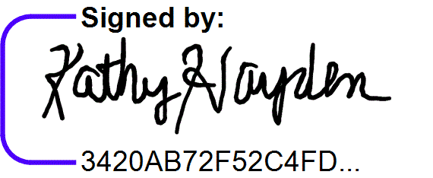**ADOPTED AND APPROVED** this 21st day of July, 2025.

Mayor Kathy Hayden

Posted: July 22, 2025

Published: July 23 & 30, 2025 on-line & July 30, 2025 printed