**NOTICE OF CANCELLATION OF THE SUMNER CITY COUNCIL**

NOTICE IS HEREBY GIVEN that the city council of the city of Sumner has cancelled the August 11, 2025, study session.

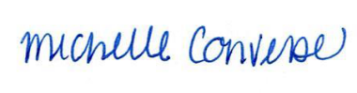

City Clerk Michelle Converse, CMC

Emailed and posted July 25, 2025