NOTICE OF THE SUMNER CITY COUNCIL

NOTICE IS HEREBY GIVEN that the City of Sumner City Council has fixed Wednesday,
August 20, 2025, beginning at 1:30pm as the time to participate in the All Sounders Soccer Celebration. The event will take place at Seibenthaler Park, 1602 Bonney Avenue, Sumner.

A quorum of the City Councilmembers is expected to be present for this event. This is not a business meeting of the Council, and no action will be taken.

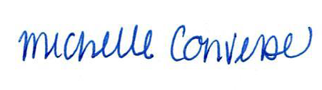
City Clerk Michelle Converse, CMC

emailed & posted August 18, 2025

