NOTICE OF THE SUMNER CITY COUNCIL

NOTICE IS HEREBY GIVEN that the City of Sumner City Council has fixed Monday,
August 25, 2025, beginning at 8am as the time to participate in the Sumner-Bonney Lake School District Convocation, located at Sunset Stadium (1707 Main Street, Sumner).

A quorum of the City Councilmembers is expected to be present for this event. This is not a business meeting of the Council, and no action will be taken.

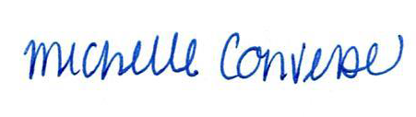
City Clerk Michelle Converse, CMC

emailed & posted August 8, 2025

