NOTICE OF THE SUMNER CITY COUNCIL
SEPTEMBER 2025

NOTICE IS HEREBY GIVEN that the City of Sumner City Council has fixed the following dates and times to participate in the following activities:

Sumner Main Street Association Annual Meeting
Wednesday, September 17, 2025 | 5:30-7:30pm | The Hansen Place, 823 Main Street A, Sumner

City of Sumner Open House
Tuesday, September 30, 2025 | 5:00-7:00pm | Sumner Senior Center, 15506 62nd St Ct E, Sumner

A quorum of City Councilmembers may be present at these events. These are not business meetings of the Council, and no action will be taken.

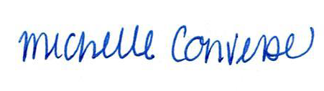
City Clerk Michelle Converse, CMC

emailed & posted September 8, 2025

Revision 1 –Location & Time Change

