

NOTICE OF SUMNER CITY COUNCIL NOVEMBER 2025 COUNCIL MEETINGS

NOTICE IS HEREBY GIVEN the City Council of Sumner has scheduled the following special council meetings in November:

NOVEMBER 17 Special Study Session
- Ordinance No. XXXX - 2025-2026 Mid-Biennial Budget Amendment
- 2025 Comprehensive Plan Amendments

NOVEMBER 24 Special Council Meeting
- Public Hearing -
Ordinance No. XXXX - 2025-2026 Mid-Biennial Budget Amendment
- 2025 Comprehensive Plan Amendments

Both meetings will begin at 6pm, in the Sumner City Hall Council Chambers, 1104 Maple Street, Sumner. Meeting agenda packets including Zoom links and will be available on the City’s website, prior to meeting dates.

NOTICE OF SUMNER CITY COUNCIL MEETING CANCELLATIONS

NOTICE IS HEREBY GIVEN the City Council of Sumner has cancelled the
November 10 Study Session.

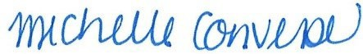
Michelle Converse, City Clerk

Emailed/posted 10/20/2025

