NOTICE IS HEREBY GIVEN that the Sumner City Council Public Works Committee has scheduled a special committee meeting. On the agenda will be:

- Forged Fiber LLC Franchise Agreement
- Wastewater Treatment Facility Biosolids Modernization — Construction Contract Award

Monday, November 24, 2025, beginning at 5:00pm at City Hall in the First Floor Conference Room. The agenda packet including the virtual meeting link will be available on the City’s website prior to the meeting date.

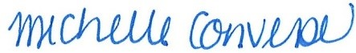

Michelle Converse, CMC
City Clerk

Posted: November 6, 2025
Emailed: November 6, 2025

