

SEPA DETERMINATION OF NON-SIGNIFICANCE (DNS)

Project Name: ZONING CODE TEXT AMENDMENT – CO-LIVING

Permit Application: SEPA-2025-0010/CTA-2025-0003

Description of Proposal: The proposed non-project action is for the City’s Co-living Housing Regulations Update. This zoning code text amendment would amend Title 18 Sumner Municipal Code – Zoning for consistency with legislation passed by the Washington State Legislature: ESHB 1998 (2024) related to co-living housing, including definitions on shared housing and density regarding sleeping units. This bill requires cities to allow co-living housing as permitted use on all lots that allow at least six multifamily residential units, including on lots that are zoned for mixed-use development.

Proponent: City of Sumner, 1104 Maple Street, Sumner, WA

Location of proposal: The proposal affects City-wide, in applicable zones. The City of Sumner is in Pierce County, WA. This proposal is not a site-specific project.

Lead Agency: City of Sumner

The lead agency for this proposal has determined that it does not have a probable significant adverse impact on the environment. An environmental impact statement (EIS) is not required under RCW 43.21C.031. This decision was made after review of a completed environmental checklist and other information on file with the lead agency. This information is available to the public on request. Documents are available on the City of Sumner website at www.sumnerwa.gov.

_____ There is no comment period for this DNS.
_____ This DNS is issued after using the optional DNS process in WAC 197-11-355. There is no further comment period on the DNS.
_X___ This DNS is issued under WAC 197-11-340 (2); the lead agency will not act on this proposal for 14 days from the date issued below.

Responsible Official: Ryan Windish, Community Development Director
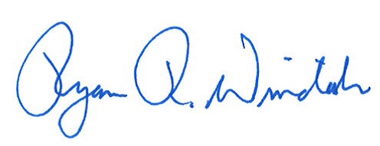
Address: 1104 Maple Street Suite 250, Sumner, WA 98390 Phone: (253) 299-5524

Signature: ________________________________ Determination Date: December 3, 2025
Ryan Windish, CD Director Date Issued: December 10, 2025____

Questions or comments: Chrissanda Walker, Associate Planner: chrissandaw@sumnerwa.gov

