

NOTICE OF SUMNER CITY COUNCIL SPECIAL COUNCIL MEETING

NOTICE IS HEREBY GIVEN the City Council of Sumner has scheduled the following special council meeting on January 26, 2026, beginning at 6:00pm, in the Council Chambers. The item for Council consideration is as follows:

  - Heritage Park Change Order for Interim Park Improvements

The regularly scheduled study session will begin at 6:10pm.

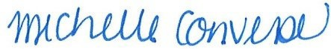
Michelle Converse, City Clerk

emailed / posted January 22, 2026

