

DATE CHANGE

NOTICE IS HEREBY GIVEN that the City of Sumner Public Works Committee has re-scheduled its regular meeting of January 6, 2026 to January 13, 2026 at 4pm, in the First Floor Conference Room at City Hall, 1104 Maple Street, Sumner.

The meeting agenda packet including the TEAMS link is available on the City’s website.

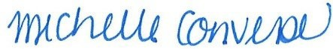
Michelle Converse, City Clerk

Posted/emailed January 6, 2026

