NOTICE OF CANCELLATIONS OF THE SUMNER CITY COUNCIL

NOTICE IS HEREBY GIVEN that the City Council of the City of Sumner has cancelled
the regularly scheduled May 5th, 2026, regular council meeting and regularly scheduled study session of May 11, 2026.

.
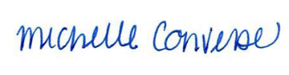
City Clerk Michelle Converse, CMC

Emailed and posted April 30, 2026

