NOTICE OF THE SUMNER CITY COUNCIL

NOTICE IS HEREBY GIVEN that a quorum of the Sumner City Council is expected to attend a Sumner Police promotional swearing-in ceremony. Please join us on Monday, April 27th, 2026, at 4:30pm in the Council Chambers of Sumner City Hall. We will be celebrating the promotions of Deputy Chief Andy McCurdy to Chief, Lieutenant Loren Houselog to Deputy Chief and Sergeant Justin Gregson to Lieutenant and Officer Geoff Boone to Sergeant.

Please note, this is not a formal business meeting of the Council, and no official action will be taken.

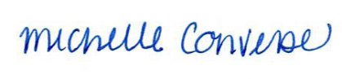
City Clerk Michelle Converse, CMC

Posted / emailed April 21, 2026

