NOTICE OF THE SUMNER CITY COUNCIL

NOTICE IS HEREBY GIVEN that a quorum of the Sumner City Council is expected to attend the 31st Annual Community Summit, Tuesday, April 28th, 2026, from 4-8:30. The Summit will take place at Calvary Community Church, 15116 Gary Street East; Sumner.

Please note, this is not a formal business meeting of the Council, and no official action will be taken.

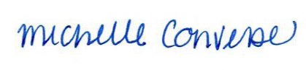
City Clerk Michelle Converse, CMC

Posted / emailed April 21, 2026

