NOTICE OF CANCELLATIONS OF THE SUMNER CITY COUNCIL

NOTICE IS HEREBY GIVEN that the City Council of the City of Sumner has cancelled
the regularly scheduled May 26th, 2026, council meeting.

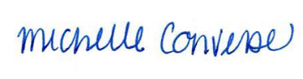
City Clerk Michelle Converse, CMC

