NOTICE OF THE SUMNER CITY COUNCIL
SPECIAL COUNCIL RETREATS

NOTICE IS HEREBY GIVEN that the City Council of the City of Sumner will participate in two Council Retreats. These retreats are open to the public; however, these are not regularly scheduled City Council business meetings, virtual attendance option will not be available and the Council will not be accepting Public Comment.

Retreat Details:

May 4, 2026
Farm 12 Restaurant | VanLierop House
3303 8th Ave SE
Puyallup, WA 98372
1:00 PM – 7:00 PM
Primary focus: 2027–2028 Budget

May 11, 2026
Holiday Inn Express & Suites
2500 136th Avenue Ct E
Sumner, WA 98390
1:00 PM – 7:00 PM
Primary focus: Major Initiatives

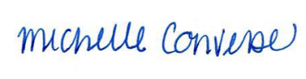
City Clerk Michelle Converse, CMC
Emailed and posted April 30, 2026

