NOTICE OF THE SUMNER CITY COUNCIL

NOTICE IS HEREBY GIVEN that a quorum of the Sumner City Council is expected to attend the Celebration of Life for Councilmember Greg Reinke, Saturday, July 18th, 2026, beginning at 1pm. The service will take place at Calvary Community Church, 15116 Gary Street East; Sumner.

Please note, this is not a formal business meeting of the Council, and no official action will be taken.

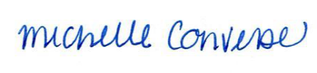
City Clerk Michelle Converse, CMC

Posted / emailed July 7, 2026

