NOTICE OF THE SUMNER CITY COUNCIL
SPECIAL COUNCIL RETREATS

NOTICE IS HEREBY GIVEN that the City Council of the City of Sumner will participate in one Council Retreat. The retreat is open to the public; however, since this is not a regularly scheduled City Council business meeting, no final action will be taken, virtual attendance will not be available, and the Council will not be accepting Public Comment.

Retreat Details:

August 31, 2026
Gordon Family YMCA
16101 64th Street East
Sumner, WA 98390
1:00PM – 7:00PM

Subjects will include an overview of general fund revenues, facilities tours and strategy discussions.

The full agenda will be available on the City’s website, Wednesday, August 26, 2026.

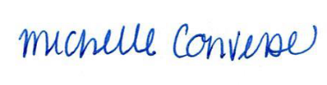
City Clerk Michelle Converse, CMC

