

NOTICE OF SPECIAL SUMNER CITY COUNCIL SPECIAL COUNCIL MEETING
NOTICE IS HEREBY GIVEN that the City Council of the City of Sumner has scheduled a special study session for September 21, 2026, beginning at 6:10pm and held at the Council Chambers, 1104 Maple Street, for the purposes of:
- 2027/2028 Preliminary Budget
- Revenue and Expense Projections
- Review and Adoption Process Overview

The agenda will be available on the City’s website by 5pm on September 17, 2026. Noon on September 18, 2026.
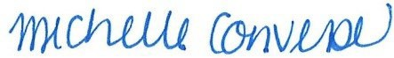
Michelle Converse, City Clerk

Posted/Emailed September 15, 2026
Revision 1 – September 17, 2026

https://sumnerwa.gov/notice-of-special-sumner-city-council-special-council-meeting-4/

