

September Meeting Change

NOTICE IS HEREBY GIVEN the regularly scheduled Council meeting
(September 7, 2026) of the Sumner City Council has been moved due to the upcoming holiday. The meeting will now be held on September 8, 2026, at Sumner City Hall, beginning at 6pm.

This is a date change of a regular meeting and is not a special meeting under the Open Public Meetings Act. Notice of this change has been provided in accordance with
RCW 42.30.075.

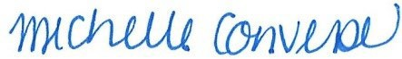
Michelle Converse, City Clerk

Emailed September 1, 2026
Posted September 1, 2026

