

Council Committee Meeting(s)

NOTICE IS HEREBY GIVEN that the following Sumner City Council Committee meeting changes and cancellations have been scheduled -

Beginning November 18th, 2026, the Public Safety Committee meetings will begin at 11am, in the Sumner City Hall first floor conference room.

The Community Development Committee has cancelled the November 25th and December 23, 2026, meeting.

The Community Development Committee will have a Special Committee meeting on December 9, 2026, beginning at 4pm in the Sumner City Hall Council Chambers.

The Finance & Personnel Committee has cancelled their meeting of
November 11, 2026.

The Finance & Personnel Committee has scheduled a Special Committee meeting on November 10th, 2026, beginning at 3:30 in the Sumner City Hall first floor conference room.

Meeting agendas will be available on the City’s website at least 24 hours in advance. All Committee meetings also provide an option for virtual attendance.

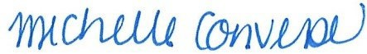
Michelle Converse, City Clerk

Emailed 10/21/2026
Posted 10/21/2026

