NOTICE OF THE SUMNER CITY COUNCIL

NOTICE IS HEREBY GIVEN that the City of Sumner City Council has fixed
Friday, October 9th, 2026, at 4:30pm as the time to participate in the Sumner High School Homecoming Parade.

A quorum of the City Councilmembers is expected to be present for this event. This is not business meeting of the Council, and no action will be taken.

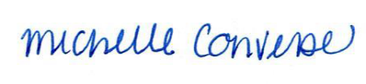
City Clerk Michelle Converse, CMC

Posted 10/5/2026

